Lab-7

Book database

**Code:**

create database book_db;

use book_db;

CREATE TABLE Publisher

(name VARCHAR(20) PRIMARY KEY,

phone real,

address VARCHAR(20));

CREATE TABLE Book

(book_id int PRIMARY KEY,

title VARCHAR(20),

pub_year VARCHAR(20),

publisher_name varchar(20) REFERENCES Publisher (name) ON DELETE CASCADE);

CREATE TABLE Book_Authors

(author_name VARCHAR(20),

book_id int REFERENCES Book (book_id) ON DELETE CASCADE,

PRIMARY KEY (book_id, author_name));

CREATE TABLE Library_Branch

(branch_id int PRIMARY KEY,

branch_name VARCHAR(50),

address VARCHAR(50));

CREATE TABLE Book_Copies

(no_of_copies int,

book_id int REFERENCES Book(book_id) ON DELETE CASCADE,

branch_id int REFERENCES Library_Branch (branch_id) ON DELETE CASCADE,

PRIMARY KEY (book_id, branch_id));

CREATE TABLE Card

(card_no int PRIMARY KEY);

CREATE TABLE Book_Lending

(date_out DATE,

due_date DATE,

book_id int REFERENCES book (book_id) ON DELETE CASCADE,

branch_id int REFERENCES Library_Branch (branch_id) ON DELETE CASCADE,

card_no int REFERENCES Card (card_no) ON DELETE CASCADE,

PRIMARY KEY (book_id, branch_id, card_no));

INSERT INTO Publisher VALUES

("MCGRAW-HILL", 9989076587, "BANGALORE"),

("PEARSON",9889076565,"NEWDELHI"),

("RANDOM HOUSE",7455679345,"HYDRABAD"),

("HACHETTE LIVRE",8970862340,"CHENNAI"),

("GRUPO PLANETA",7756120238,"BANGALORE");

INSERT INTO Book VALUES

(1,"DBMS","JAN-2017","MCGRAW-HILL"),

(2,"ADBMS","JUN-2016","MCGRAW-HILL"),

(3,"CN","SEP-2016","PEARSON"),

(4,"CG","SEP-2015","GRUPO PLANETA"),

(5,"OS","MAY-2016","PEARSON");

INSERT INTO Book_Authors VALUES

("NAVATHE", 1),

("NAVATHE", 2),

("TANENBAUM", 3),

("EDWARD ANGEL", 4),

("GALVIN", 5);

INSERT INTO Library_Branch VALUES

(10,"RR NAGAR","BANGALORE"),

(11,"RNSIT","BANGALORE"),

(12,"RAJAJI NAGAR","BANGALORE"),

(13,"NITTE","MANGALORE"),

(14,"MANIPAL","UDUPI");

INSERT INTO Book_Copies VALUES

(10, 1, 10),

(5, 1, 11),

(2, 2, 12),

(5, 2, 13),

(7, 3, 14),

(1, 5, 10),

(3, 4, 11);

INSERT INTO Card VALUES

(100),

(101),

(102),

(103),

(104);

INSERT INTO Book_Lending VALUES

("2017-01-01","2017-06-01", 1, 10, 101),

("2017-01-11","2017-03-11", 3, 14, 101),

("2017-02-21","2017-04-21", 2, 13, 101),

("2017-03-17","2017-07-15", 4, 11, 101),

("2017-04-12","2017-05-12", 1, 11, 104);

Queries and screenshot:

**1.** Retrieve details of all books in the library – id, title, name of publisher, authors, number of copies in each branch, etc.

**2.** Get the particulars of borrowers who have borrowed more than 3 books, but from Jan 2017 to Jun 2017

**3.** Delete a book in BOOK table. Update the contents of other tables to reflect this data manipulation operation.

**4.** Partition the BOOK table based on year of publication. Demonstrate its working with a simple query.

**5.** Create a view of all books and its number of copies that are currently available in the Library.

**1.** select l.branch_id,b.book_id,b.title,p.name,ba.author_name,bc.no_of_copies from Library_Branch l, Book_Copies bc,Publisher p,Book b,Book_Authors ba

where

l.branch_id=bc.branch_id and

bc.book_id=b.book_id and

b.book_id=ba.book_id and

b.publisher_name=p.name;

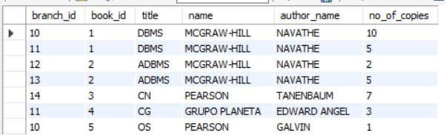

**2.** select card_no from Book_Lending

where date_out between "2017-01-01" and "2017-06-30"

group by card_no

having count(*)>3;

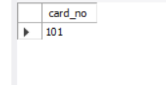

**3.** delete from Book where book_id=1;

Select * from book;

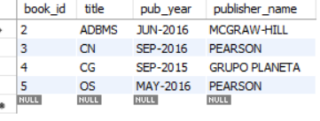

**4.**

create view Year_Publishing as

select pub_year,publisher_name,title from Book;

select * from Year_Publishing;

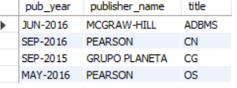

**5.**

create view Book_Copies_Library as

select b.title,bc.no_of_copies,bl.branch_name from Library_Branch bl,Book_Copies bc,Book b

where bl.branch_id=bc.branch_id and

bc.book_id=b.book_id;

select * from Book_Copies_Library;

